**Spring Core and Maven**

Exercise 1: Configuring a Basic Spring Application

Code:

<project xmlns="http://maven.apache.org/POM/4.0.0"

xmlns:xsi="http://www.w3.org/2001/XMLSchema-instance"

xsi:schemaLocation="http://maven.apache.org/POM/4.0.0

http://maven.apache.org/xsd/maven-4.0.0.xsd">

<modelVersion>4.0.0</modelVersion>

<groupId>com.example</groupId>

<artifactId>SpringBasicApp1</artifactId>

<version>1.0-SNAPSHOT</version>

<dependencies>

<!-- Spring Core / Context -->

<dependency>

<groupId>org.springframework</groupId>

<artifactId>spring-context</artifactId>

<version>5.3.33</version>

</dependency>

</dependencies>

<build>

<plugins>

<!-- To run the main method via Maven -->

<plugin>

<groupId>org.codehaus.mojo</groupId>

<artifactId>exec-maven-plugin</artifactId>

<version>3.1.0</version>

</plugin>

</plugins>

</build>

</project>

package com.example;

public class GreetingService {

public void sayHello() {

System.***out***.println("Hello from Spring!");

}

}

<?xml version="1.0" encoding="UTF-8"?>

<beans xmlns="http://www.springframework.org/schema/beans"

xmlns:xsi="http://www.w3.org/2001/XMLSchema-instance"

xsi:schemaLocation="

http://www.springframework.org/schema/beans

http://www.springframework.org/schema/beans/spring-beans.xsd">

<bean id="greetingService" class="com.example.GreetingService" />

</beans>

package com.example;

import org.springframework.context.ApplicationContext;

import org.springframework.context.support.ClassPathXmlApplicationContext;

public class App {

public static void main(String[] args) {

ApplicationContext context = new ClassPathXmlApplicationContext("applicationContext.xml");

GreetingService service = context.getBean("greetingService", GreetingService.class);

service.sayHello();

}

}

**Output:**

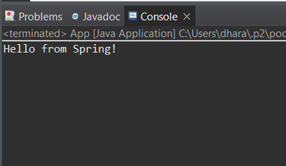

**Exercise 2: Implementing Dependency Injection**

**Code:**

package com.example;

public interface MessageService {

void sendMessage(String message);

}

package com.example;

public class EmailService implements MessageService {

public void sendMessage(String message) {

System.***out***.println("Email sent with message: " + message);

}

}

package com.example;

public class MessageClient {

private MessageService messageService;

// Setter for Dependency Injection

public void setMessageService(MessageService messageService) {

this.messageService = messageService;

}

public void processMessage(String msg) {

messageService.sendMessage(msg);

}

}

<?xml version="1.0" encoding="UTF-8"?>

<beans xmlns="http://www.springframework.org/schema/beans"

xmlns:xsi="http://www.w3.org/2001/XMLSchema-instance"

xsi:schemaLocation="

http://www.springframework.org/schema/beans

http://www.springframework.org/schema/beans/spring-beans.xsd">

<bean id="emailService" class="com.example.EmailService" />

<bean id="messageClient" class="com.example.MessageClient">

<property name="messageService" ref="emailService" />

</bean>

</beans>

package com.example;

import org.springframework.context.ApplicationContext;

import org.springframework.context.support.ClassPathXmlApplicationContext;

public class App {

public static void main(String[] args) {

ApplicationContext context = new ClassPathXmlApplicationContext("applicationContext.xml");

MessageClient client = context.getBean("messageClient", MessageClient.class);

client.processMessage("Spring Dependency Injection works!");

}

}

**Output:**

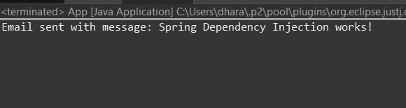

**Exercise 4: Creating and Configuring a Maven Project**

**Code:**

<project xmlns="http://maven.apache.org/POM/4.0.0"

xmlns:xsi="http://www.w3.org/2001/XMLSchema-instance"

xsi:schemaLocation="http://maven.apache.org/POM/4.0.0

http://maven.apache.org/xsd/maven-4.0.0.xsd">

<modelVersion>4.0.0</modelVersion>

<groupId>com.example</groupId>

<artifactId>SpringMavenProject</artifactId>

<version>1.0-SNAPSHOT</version>

<dependencies>

<!-- Spring Core -->

<dependency>

<groupId>org.springframework</groupId>

<artifactId>spring-context</artifactId>

<version>5.3.33</version>

</dependency>

</dependencies>

<build>

<plugins>

<!-- For running main class -->

<plugin>

<groupId>org.codehaus.mojo</groupId>

<artifactId>exec-maven-plugin</artifactId>

<version>3.1.0</version>

</plugin>

</plugins>

</build>

</project>

package com.example;

public class HelloService {

public void greet() {

System.***out***.println("Hello from Spring!");

}

}

<?xml version="1.0" encoding="UTF-8"?>

<beans xmlns="http://www.springframework.org/schema/beans"

xmlns:xsi="http://www.w3.org/2001/XMLSchema-instance"

xsi:schemaLocation="

http://www.springframework.org/schema/beans

http://www.springframework.org/schema/beans/spring-beans.xsd">

<bean id="helloService" class="com.example.HelloService" />

</beans>

package com.example;

import org.springframework.context.ApplicationContext;

import org.springframework.context.support.ClassPathXmlApplicationContext;

public class App {

public static void main(String[] args) {

ApplicationContext context = new ClassPathXmlApplicationContext("applicationContext.xml");

HelloService service = context.getBean("helloService", HelloService.class);

service.greet();

}

}

**Output:**

